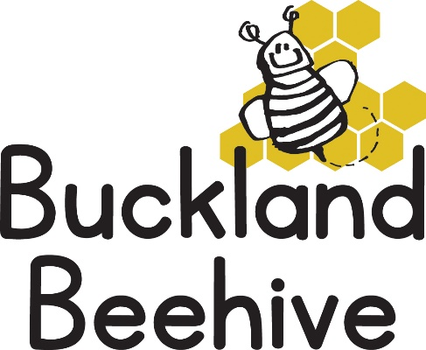

14th October 2024

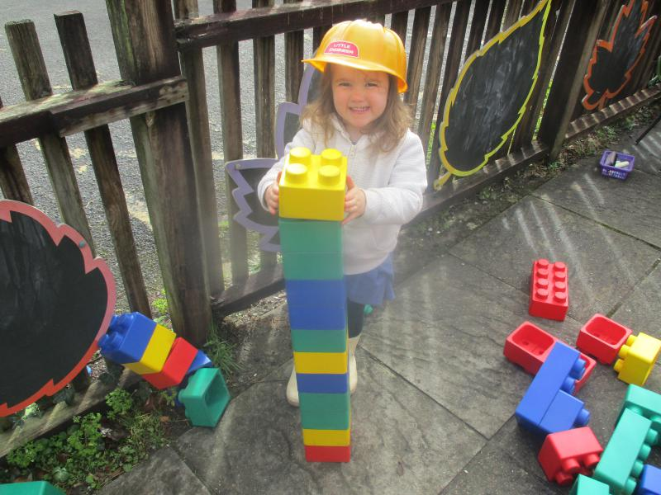We talked all about our houses last week, and some of the children did some serious building with the bricks, and they all made a craft house for our theme board.

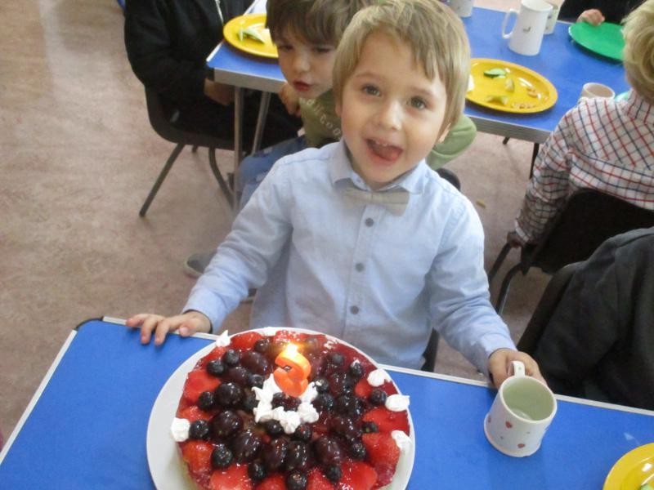We also made some jelly, this is a great activity for senses, as it smells good, feels wobbly, tastes good, makes squelchy sounds and looks great. We all had it for snack the next day.

Olena, Timur’s mum, made a fabulous fruit tart for his birthday, which we shared with all the children. It was a delicious Ukrainian surprise! Thank you so much, we all enjoyed it!

This week we are talking about the clothes we wear, and the different clothes worn in different seasons, as well as uniforms. Lots of opportunity to dress up this week.

As the garden is becoming rather muddy, please try and remember to send in your child’s named wellies and waterproofs.

Many Thanks