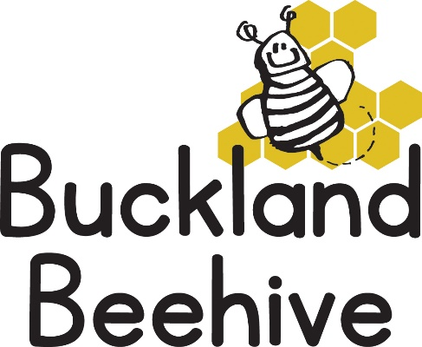

30th September 2024

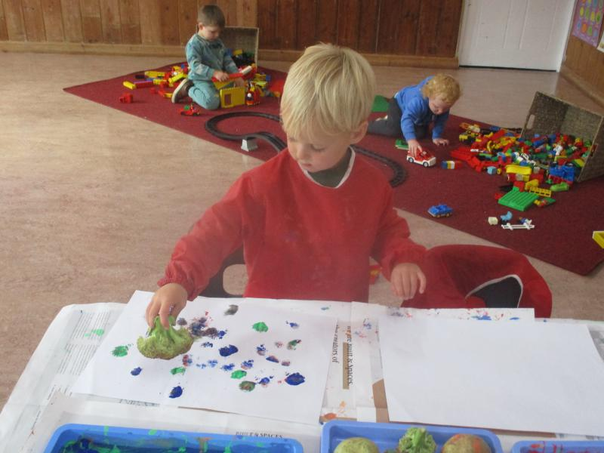The children made loads of vegetable prints last week as part of our healthy eating week! with broccoli, carrots and potatoes in the paint it was a huge novelty.

We spent some time sorting out which foods were healthy and which foods were a treat, of course we all loved the treats!

This week we will be learning all about our five senses. We will have an Opticians shop set up, a table full of smells, we will be making jelly and putting shaving foam on the sensory table and making lots of noise with the musical instruments.

We will be welcoming George to Preschool for the first time on Tuesday.

On Wednesday, Addy will return for another music & movement session and on Thursday afternoon we will have our muddy day session at the school. So, another busy week for us all.

Please remember to name your child’s wellies, coats, waterproofs, lunchbox and water bottles, it really helps us when preparing the children for going home.

Many Thanks