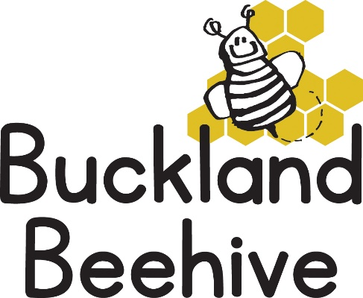

2nd September 2024

Welcome to the Autumn Term, we hope you have all had a fabulous summer!

The theme for this term is “All about us”, which will give our new children the opportunity to get to know their peers, learn each others names, learn about our skeleton, healthy eating, exercise, where we live, what we wear and people who help us.

This week, as it is only two days, we are just going to let the children relax and settle back into the Preschool routine and next week we will start with learning about what we look like.

If you have a **spare shoebox**, please send it in with your child, we will be making them into colourful boxes which will hold treasures and momentous about each child, which could be photos of family, holidays or pets. We will keep them at Beehive and send them home at the end of this half term.

It is difficult to know what the weather will be doing, so if it is sunny, please continue to apply sun cream to your child before they arrive at Beehive. We are unable to apply the creams as we have children with allergies to some makes, and I am sure you can imagine if we have to cover 20 children before we go out to play, we would never have any time outside! Also send them in with a sun hat. We aim to spend as much time as we can outside.

If the weather turns to rainy days, each child will need boots and an all weather suit. It can get very muddy especially in our environmental garden at the rear of the hall.

A reminder to send in a **named bottle of water** for your child, it is an Ofsted requirement that all children have access to a drink throughout their day. In fact, please ensure that boots, coats, hats, lunchboxes etc. are all named, it makes our job so much easier when preparing to go home.

We have a number of new children starting at various times this term, so we would like to welcome Hattie, Annie, Woody, Henderson, Polly, Sabine and Evelyn. We hope they all settle in and enjoy the activities that we have available.

We also have a new member of Staff, Amber, she will be at Beehive on a Wednesday, Thursday and Friday. She is very excited to start this week and looking forward to getting to know her key children.

For our new parents, I send out a weekly newsletter explaining what we will be learning in the following week, as well as telling you how the previous week went. We do take photographs of the children throughout the week, which I post on our website in the “Parent Gallery” which is password protected. We are happy to give this to you upon request. We also use the photographs to make a scrapbook of your childs time spent at Beehive, this is given to you when your child leaves us for school.

If you have any questions, please email me on [bucklandbeehive@hotmail.com](mailto:bucklandbeehive@hotmail.com) or ask Tara, Angie, Amber or myself when dropping off or collecting your child. We are always happy to help in anyway we can.

Many Thanks