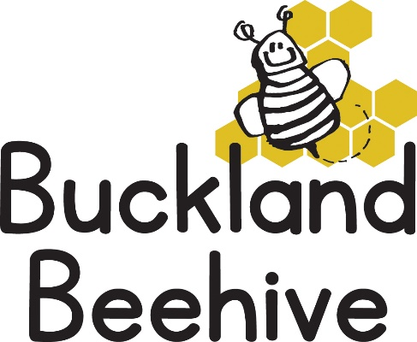

9th September 2024

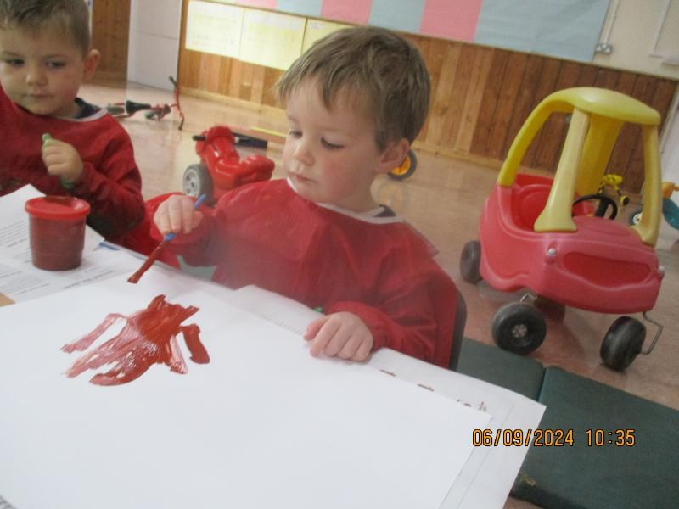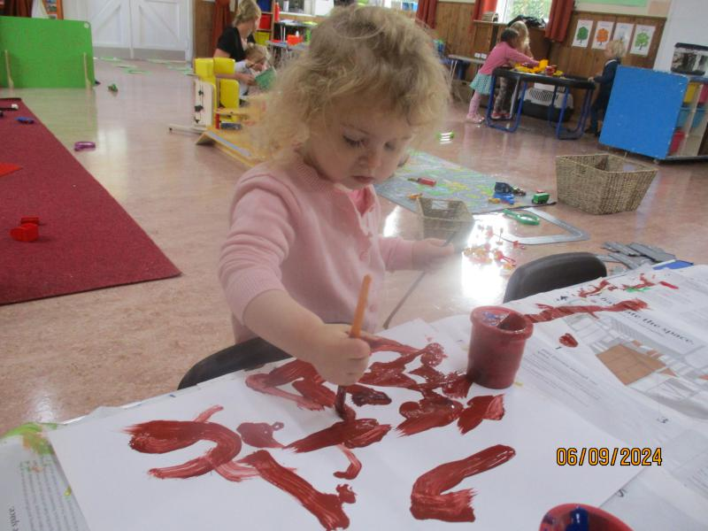It was a very short week to start our new term, but already we seemed to achieve a lot. It is lovely to see the children return and to welcome some new children. Although we had tears from some of them, I can assure you they all settled and enjoyed the activities we had for them to play with.

Especially the painting!

This week we will be starting to really look at our theme of “All about us” we will be making paper plate faces of ourselves for our display board, and we will be starting to decorate our shoeboxes. Activities this week will include making fairy cake faces, playdough, dressing up clothes and the playhouse.

We will be starting to introduce listening games at circle time, over time as the children get used to the routine, we find these short fun games really effective in helping the children to learn to listen. Which in turn will be a great benefit for when they start in Foundation. We will also be taking the Butterfly Group, who are all starting school in September 2025, for adult led activities where they will be learning their numbers, colours and shapes this term.

Please continue to bring in a shoebox for your child to decorate, we do have some spares if you don’t have one. Thank you for all the named coats, boots and drinks bottles, it makes it so much easier when preparing your children for home time.

On a Wednesday morning, we will be starting a Music & Movement session after snack time. Addy Varley, who is Dougie’s Grandma, is a dance teacher and she has agreed to come in and put together some sessions for the children to take part in.

Also, on a Wednesday afternoon we will be taking the children that are booked in, to a muddy day session at the school with Foundation class. I will let you know when these sessions will begin, the children will need full waterproofs and wellies to take part.

Many Thanks