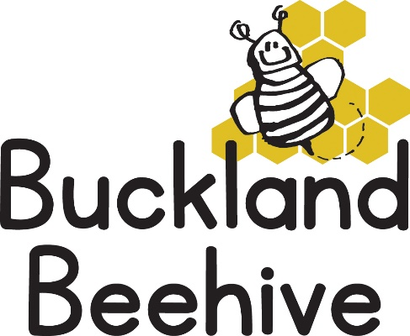

21st October 2024

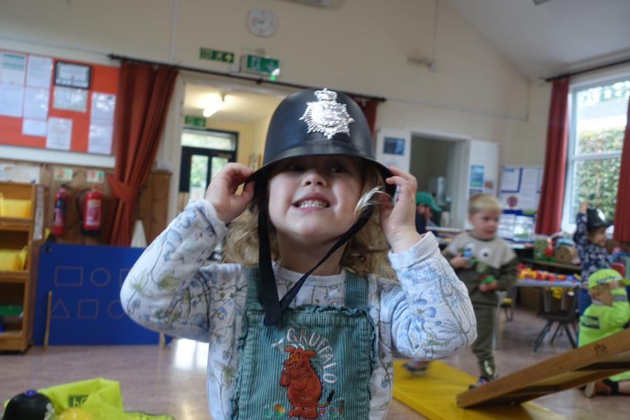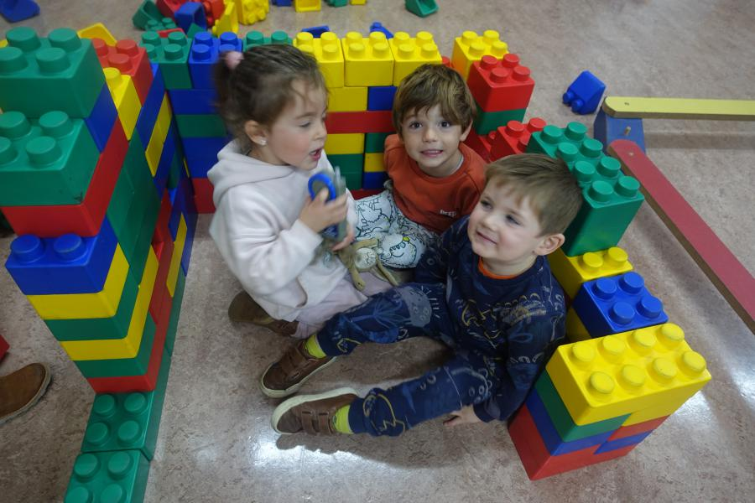We spent the week talking about the different clothes that we wear, the children had fun dressing up and building with the large bricks, it was as much fun building a den as it was knocking it down!

Some of the children made some Autumn pictures with leaves they collected in the garden and we decorated dolls with different types of fabric.

This week is our last week until half term. We are celebrating Halloween, so if the children want to come dressed up they can. We have pumpkins in the sensory table, and red lentils in the sandpit! To end our theme, we will be talking about People who help us, so we will have dressing up for doctors, Firemen, Nurses and Police Officers.

We are encouraging the children to be as self sufficient as possible, so please encourage them to put on their own shoes and coat themselves, it can take a lot longer but they are really pleased when they achieve it. We hand out stickers to them when they are successful.

We hope you all have a fabulous half term holiday and we look forward to seeing you again week beginning the 4th November.

Many Thanks for your support this term.