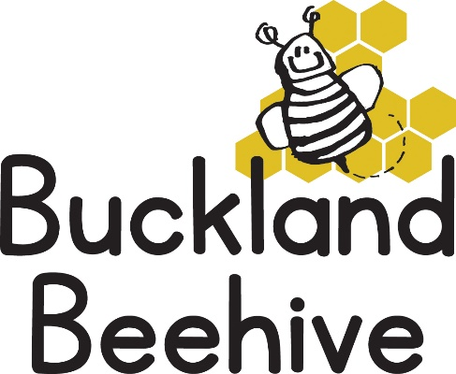

7th October 2024

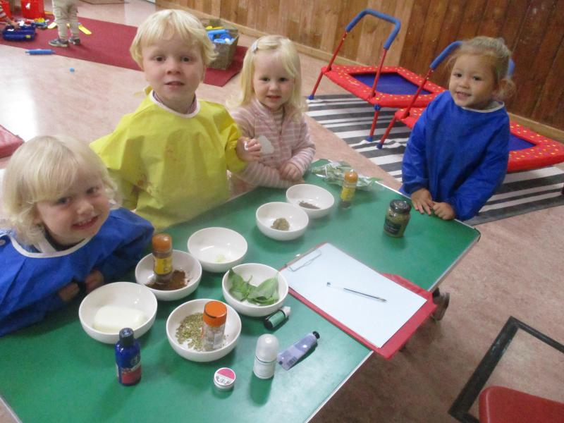Our senses week was a great success, with the children using their noses on our “smelly” table to see which they liked and which smells they didn’t like. Mustard was a definite dislike for all the children and likewise they all wanted to be squirted with perfume!

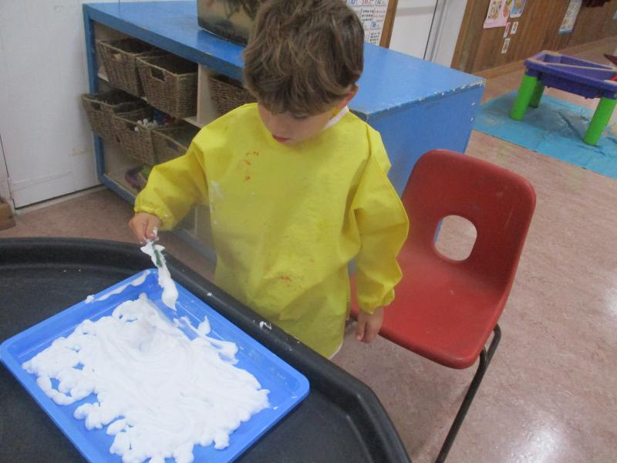

We had shaving foam on the sensory table, which not only smelt but was great to feel.

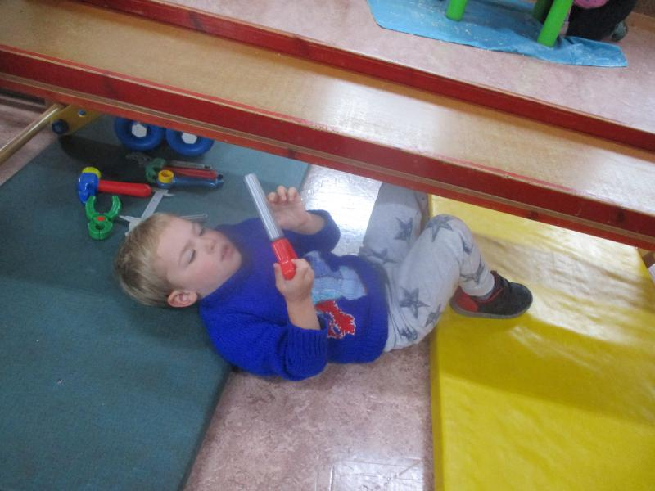The construction toys were in good use, with lots of banging and mending of the slide, as you can see it was taken very seriously.

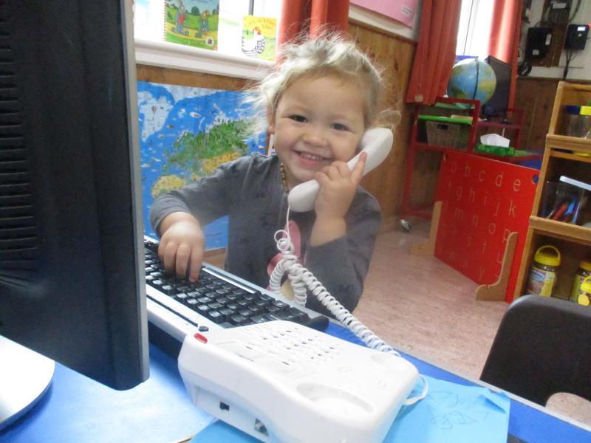We also had different snacks that were crunchy and soft.

The opticians shop was also busy with the children trying on different glasses.

This week we are looking at where we live, taking walks around the village and making maps to guide us, sticking and gluing our houses. Activities include the dolls house and furniture, the playhouse, dolls and prams, and Happyland and much more.

You could send in a picture of your house for the children’s shoeboxes if you can.

You may have noticed we have put the Registration Tree outside the front door. We like to encourage the children to find their leaf and put it on the tree, which signifies that they are at Preschool. It is also a tool to help them to recognise their names, in time. Rather than parents finding the leaf, try and encourage your child to look for the first letter of their name and show them what it looks like, you will be surprised to see how quickly they get to recognise it.

**On Saturday 12th October 10am until 12 noon** the village hall will have a coffee morning with various stall holders selling their wares. These include cakes, dog products, craft stall and candles and this month I am having a table with my childminding toys that I am selling. I have puzzles, a castle, megabloks, small Thomas train track, games, play food, cutlery and utensils and much more.

Do come along and have a look, all in good condition, everything must go so I am very flexible on price and we do have Christmas coming up!!

Many Thanks