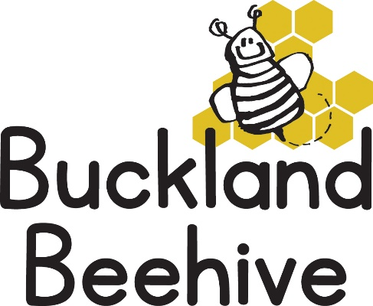

16th September 2024

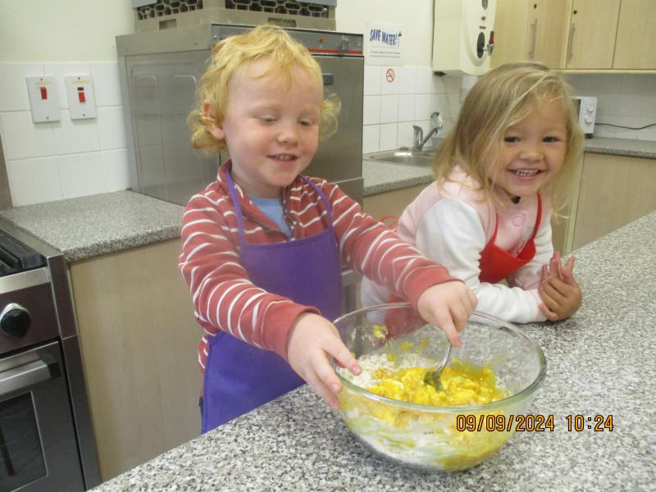We had a lot of fun this week making our paper plate faces, all of which are on display on our theme board and making fairy cakes with faces on.

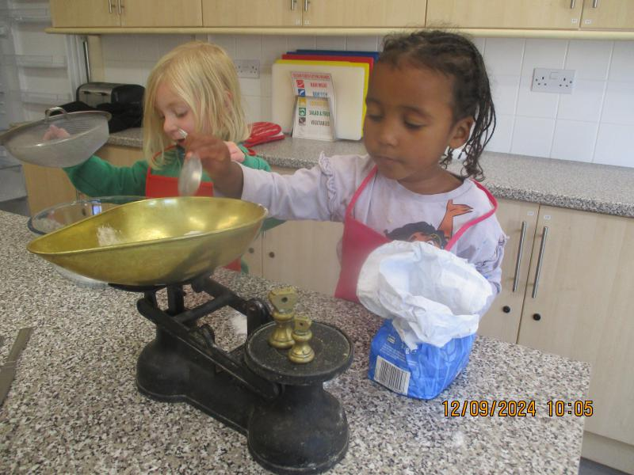Some children taking it more seriously than others!

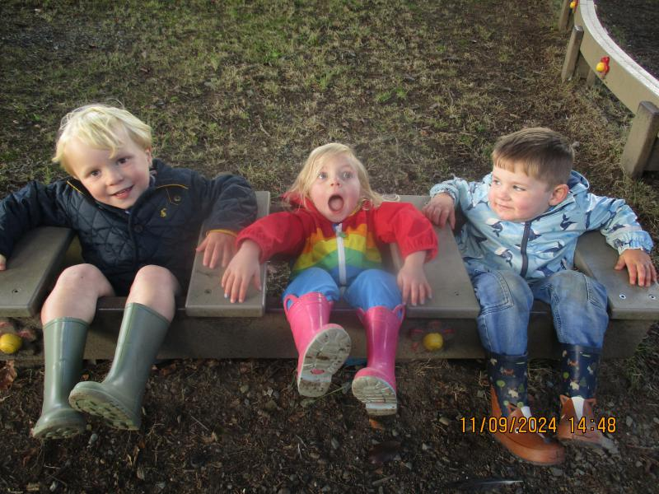

With the weather being a little better we had ample opportunity to play outside, especially in our environmental garden where these three monkeys were very entertaining!

We had our first Music & Movement session, which the children enjoyed, Addy is going to come equipped with more fun movements next week.

I was contacted by St Andrews School requesting a change to the muddy day session, so it is now on a Thursday afternoon. If your child attends this session, please can you ensure we have their wellies and a waterproof suit, we will be starting this week on the 19th.

We will be learning all about our skeleton and the parts of the body this week. Making skeleton pictures and bone biscuits! We will be doing lots of singing “Heads, Shoulders, knees and toes” and reading skeleton books.

On Thursday morning we will have an extra helpful pair of hands, a student doing volunteering for his Duke of Edinburgh award will be joining us. Sebastian is 18 years old, and he used to be one of my childminding children when he was 2 years old! Some of you may remember his sister Amelie, who volunteered with us last year.

Just a reminder to you all, if your child hasn’t slept well the night before a session, or had a fall or frightening experience, it is really useful for us to know when you drop off. Sometimes experiences affect the children and if we spot unusual behaviour, grumpiness or being extra emotional, we can be prepared to provide extra support. You can always write in their yellow book it is a two way communication tool, so don’t be afraid to use it.

Also, if you have administered calpol to your child in the morning, please do not bring them to Preschool. If they need some medicine it may be that they are fighting some bug or infection, and by 11am when the Calpol has worn off they may become fractious and we will be contacting you to collect them. It also means that if they are poorly, they may spread the infection to the other children or adults.

This week it is Headcount week, one of us will be asking you to sign the Headcount form confirming the amount of voucher hours your child attends at Preschool. I can then claim the hours through the Provider Portal on your behalf.

Many Thanks