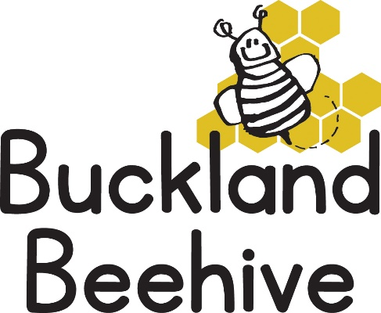

23rd September 2024

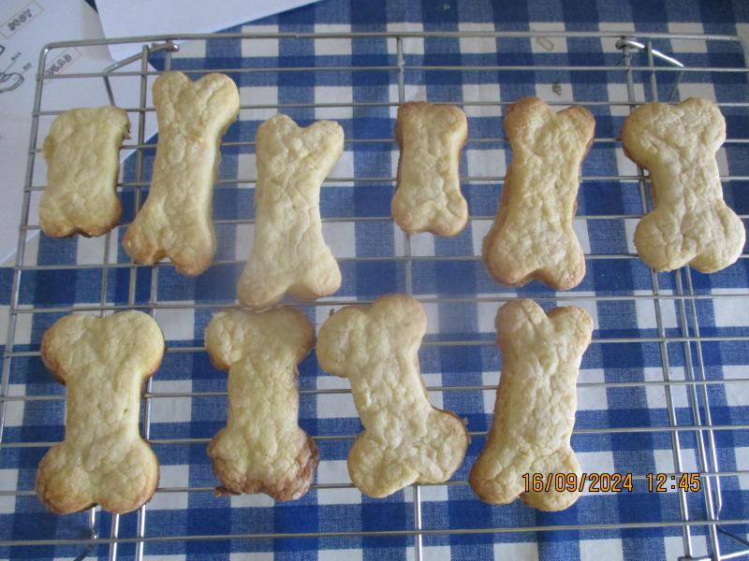We had a busy week talking about our skeleton and making bone biscuits!

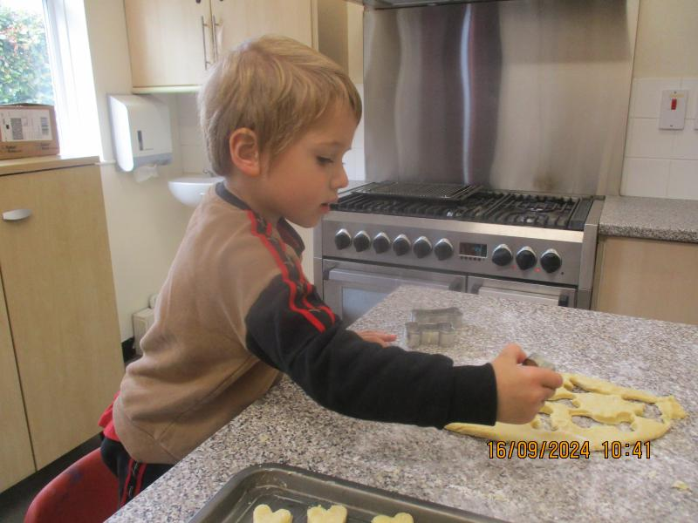We learnt the names of the parts of our bodies, with fun songs and during our music & movement session.

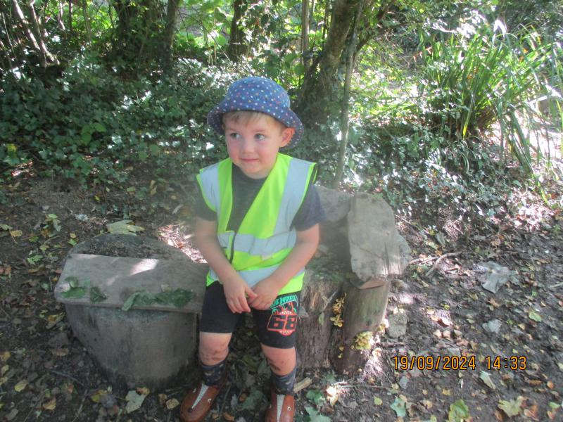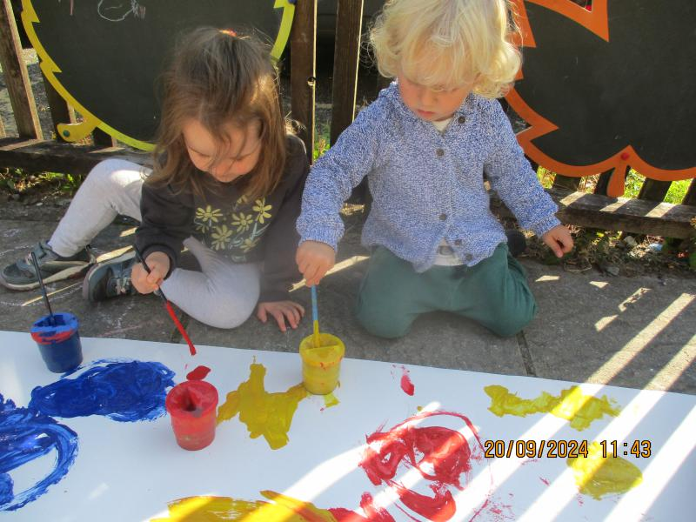Luckily the weather remained dry all week so we took the painting activity outside! There are more photos on the website.

Then on Thursday afternoon we had our first muddy day session with Foundation class. It was lovely to see the children that came to Beehive last year, everyone was very excited. Beehive children were not quite sure what to make of it initially, but soon joined in. **We will need wellies and waterproofs every Thursday please**. This is also a great opportunity for our children to meet Mrs Murdoch and her staff and to become familiar with the school environment, which will be invaluable when they start in Foundation.

This week we are talking about Healthy Eating, we will be doing vegetable printing for craft, making fruit kebabs for snack and playing in the home corner.

We will be welcoming sisters Hattie and Annie to Beehive! and I have invited Debbie Nunn the new Headteacher of St. Andrews School, to pay us a visit on Thursday morning. As we are always looking to improve our links with the School I felt it would be a good opportunity for her to see a session in progress and meet the Beehive Team.

We have a Show and Tell session every day just before lunchtime on the literacy mat. So if your child would like to bring something special to show everyone it is a good opportunity to encourage their confidence at talking to everyone, or just to stand up in front of all the children. It can be a special toy, or something linked to our theme or even just some exciting news to tell.

Many Thanks